Dialogue Trigger

This scrip is using the Unity UI systems because is triggering the Dialogue with an onscreen button. This script is attached to the NPC that will communicate with the player in this Dialogue.

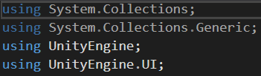

Referring to the Dialogue Manager it will make the text boxes created in Tutorial #1 appear in the Inspector.

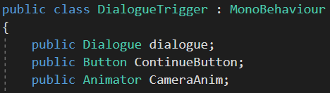

In these lines are created links to the Dialogue and the Button that will display next Sentence. Also, a link to the Camera Animator is being created, but is only for the purposes of the whole project and it is not necessary for the functioning of the Component.

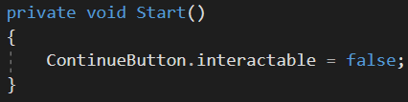

The program will start with the Continue Button as inactive until the Dialogue start.

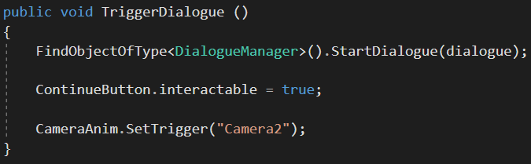

Once the Dialogue is being triggered the code will find the Empty Game Object that contains Dialogue Manager script and switch the Continue Button as active. The last line of this script triggers the Camera Animation once the Dialogue starts but remember that this is only for the visual purposes of this project and it is not necessary for the functioning of the Component.